**10 INTERESTING FACTS WE BET YOU DIDN’T KNOW ABOUT RAEES ACTRESS - MAHIRA KHAN**

 By [Shweta Kulkarni](http://www.liveinstyle.com/blogger/shweta-kulkarni-5701) 25 Jan, 201762 Shares

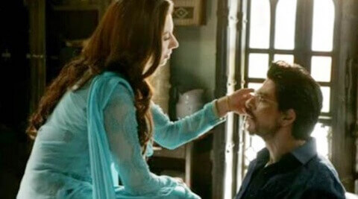

[PreviousNext](http://www.liveinstyle.com/celebrity-news/10-interesting-facts-we-bet-you-didn%E2%80%99t-know-about-raees-actress-%E2%80%93-mahira-khan?utm_source=taboola&utm_medium=ndtv&utm_content=10+Interesting+Facts+We+Bet+You+Didn%E2%80%99t+Know+About+Raees+Actress+%E2%80%93+Mahira+Khan&utm_campaign=LISMobile#myCarousel)

While the **Raees** actress couldn’t promote her Bollywood debut film, where she shares screen space with none other than the **Baadshah** of Bollywood — Shah Rukh Khan, we bring to you some interesting facts on this Pakistani beauty.

Here are ten things that perhaps you didn’t know about Mahira Khan.

1. Mahira has grown up watching Hindi films and is complete Bollywood buff. She actually wanted to host a quiz show on Bollywood.

2. The **Raees** actress who unfortunately couldn’t promote her film because of the current ban on Pakistani artists wishes that there were no boundaries for art and artistes. She quoted in an interview – “I wish art and artists had no boundaries like birds who can fly anywhere without restrictions.”

3. Mahira Khan had become a household name in India much before her dream Bollywood debut — **Raees**, courtesy her Pakistani TV show **Humsafar** with Fawad Khan.

4. Interestingly, Mahira’s family originally hails from India. Her father, Hafeez Khan, was born in Delhi during the British Raj and migrated to Pakistan after the partition of India. Mahira confessed in an interview, “My grandmother would talk about Meerut, but now there is no family this side of the border. When I was leaving for Mumbai, I was told to meet someone’s aunt’s cousin uncle.... you get the drift.”

5. Her favourite B-Town star happens to be Shah Rukh Khan so it was obviously quite a high for her to work with him. She believes that Ranbir Kapoor has a similar potential.

6. Mahira loves Mumbai’s street food, right from vada pavs to the dosas to the bhel, she is a big fan of all the typical roadside food.

7. She still makes wishes when she passes through tunnels, believing that tunnels have the power to make her wishes come true.

8. Even as a kid, Mahira wanted to be a movie star and has worked hard to accomplish her dream.

9. Mahira is an extremely sensitive person. She revealed, “I’ve always been sensitive and over-emotional. And things get to me way more. I’ve never allowed myself to become cold. So, I’d rather go through the pain of feeling something fully than to become cold, which may be difficult but I’ve never allowed that to happen.”

10. There is only one man in Mahira’s life, who she adores immensely, her son Azlaan.

*Image credits: InUth.com, Masala, Instagram*

**Click here for**[**latest celebrity news updates**](http://www.liveinstyle.com/lifestyle/celebrity-news)